**Changing Visual Attributes**

Once you have built a basic plot, you can customize its visual attributes, including changing the title color and font, adding labels for xaxis and yaxis, changing the color of the axis ticks, etc. All these properties are illustrated in the diagram below: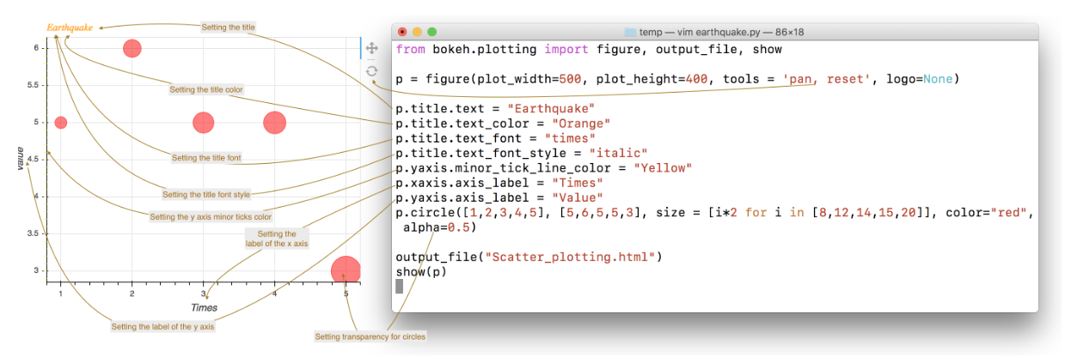

And here is the code if you want to play around with it: